**Name: Muhammad Shoaib Khan**

**Seat Number: B12101087**

**Class: BSCS 2nd Year (Section A)**

**Object-Oriented Programming**

**(Assignment 3)**

**Object 1: Write a program in C# to validate password to log on to an application using if-else condition:**

using System;

using System.Collections.Generic;

using System.Linq;

using System.Text;

using System.Threading.Tasks;

namespace password

{

class Program

{

static void Main(string[] args)

{

int password = 12345;

int a=0;

Console.WriteLine("Hello user welcome to the program");

Console.WriteLine("Please enter your password for accessing:");

a = Convert.ToInt32(Console.ReadLine());

if(a==password)

{

Console.WriteLine("Access Granted");

Console.ReadKey();

}

else

{

Console.WriteLine("Sorry, but your password is incorrect.");

Console.ReadKey();

}

}

}

}

**OUTPUT:**

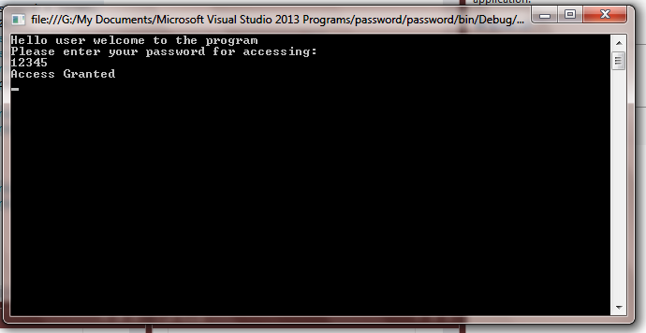

**Object 2: Write a program in C# for checking all relational conditional using relational operations:**

using System;

using System.Collections.Generic;

using System.Linq;

using System.Text;

using System.Threading.Tasks;

namespace Relational_Operators

{

class Program

{

static void Main(string[] args)

{

int a = 0, b = 0;

Console.WriteLine("Please enter two integer values: ");

a = Convert.ToInt32(Console.ReadLine());

b = Convert.ToInt32(Console.ReadLine());

if(a==b)

Console.WriteLine("Both values are equal.");

if(a!=b)

Console.WriteLine("Both values are unequal.");

if (a > b)

Console.WriteLine("First value is greater than second value.");

if (a >= b)

Console.WriteLine("First value is greater than or equal to second value.");

if (a < b)

Console.WriteLine("First value is less than second value.");

if (a <= b)

Console.WriteLine("First value is less than or equal to second value.");

Console.ReadKey();

}

}

}

**OUTPUT:**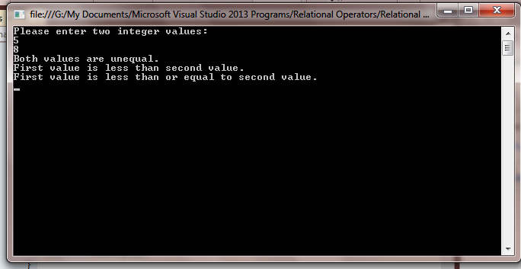

**Object 3: Write a C# program to swap two integers values through user-defined function using regerence type parameters in C#:**

using System;

using System.Collections.Generic;

using System.Linq;

using System.Text;

using System.Threading.Tasks;

namespace Reference_swap

{

class Program

{

public static void swap(ref int a, ref int b)

{

int c = a;

a = b;

b = c;

}

static void Main(string[] args)

{

int x = 10, y = 20;

Console.WriteLine("x={0}, y={1}", x, y);

swap(ref x, ref y);

Console.WriteLine("x={0}, y={1}", x, y);

Console.ReadLine();

}

}

}

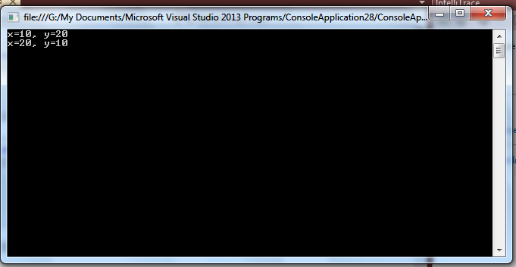

**February 28**

Numerical Register Reminder-1 DUE

**All Examples, Review Questions, and Numerical Problems of Chapter-1 of Floyd should now be done.  
  
Please update your Numerical Register till 28-02-2014.**